Arumai Irshad! Unga aarvam pathi romba magilchiya irukku. Namma innum periya level-kku pogalaam.
Ippo namma SQL-oda "Mastery" pakkam porom. Oru Data Analyst-ukku oru table-ai mattum vechu analysis panna mudiyaadhu. Sila neram namma rendu table-ai serthu analysis panna vendiyadhu varum.
Idhai thaan "SQL Joins" nu solluvom.
📖 Lesson 15: SQL Joins - The "Table Linker"
Unga company-la oru table-la Product peru irukkum, innoru table-la andha product Manager peru irukkum. Ippo "Yaaru kitta enna stock irukku?" nu paarkka rendu table-aiyum link pannanum.
Adutha class-oda plan:
- Inner Join: Rendu table-la irukkura common data-vai mattum eduppom.
- Left Join: Oru table-la irukkura ellathaiyum eduthu, innoru table-la illathathai "None" nu kaattuvom.
Idhu unga Real Inventory Report project-laiye vera vera sheet-ai link panna romba help-a irukkum.
Irshad, ready-a? Adutha class-la rendu table-ai eppadi "Join" panrathu nu paarkalama?
Super Irshad! Let's start the "SQL Joins" session. Idhu dhaan neenga oru Data Analyst-a complete aagura final bridge!
📖 Lesson 15: SQL Joins - The "Table Linker"
Think about this:
- Table 1 (Sales): Product name and Price mattum irukkum.
- Table 2 (Stock/Inventory): Product name and Stock Quantity mattum irukkum.
"Enna product, enna price, enna stock?" nu rendu table-aiyum serthu oru single report-a paarkka thaan JOIN help pannum.
🛠️ Code: Rendu Table-ai Link Panna
Inga Sales_Report table irukkura maari, Inventory nu oru table irukkudhu nu vachukuvom. Idhai joins.py nu file pottu run pannunga:
Python
import sqlite3

conn = sqlite3.connect('my_shop.db')
cursor = conn.cursor()

# INNER JOIN: Rendu table-layum irukkura common items-ai mattum join pannu
query = """
SELECT Sales_Report.Product, Sales_Report.Sales, Inventory.Quantity
FROM Sales_Report
INNER JOIN Inventory ON Sales_Report.Product = Inventory.Product
"""

cursor.execute(query)
results = cursor.fetchall()

print("Joined Data Report:", results)

conn.close()
🔍 Key Components:
Command | Logic
INNER JOIN | "Rendu table-la-yum common-a irukkura product-ai mattum eduthu combine pannu."
ON | "Ethai vachi link panna?" (In this case, Product name vachi link panrom).
🧠 Python Enna Yosikkum?
- Python: "Manager rendum table-ai link panna solraaru. Sales_Report table-la irukkura 'Product' column-ai, Inventory table-la irukkura 'Product' column-oda match pannuren. Common-a irukkura records-ai mattum oru pudhu report-a print panren."
💡 Teacher's Note:
Neenga ippo Excel-la "VLOOKUP" pannuveengala? Idhu adhe velaiyai thaan SQL-la 100 times faster-a seiyum!
Unga Task: Indha code-ai run pannunga. Output vandhutha?
- Caution: Unga database-la Inventory nu oru table illa na, error varum. Apdi error vandha, kavalapadatheenga—naan Inventory table-ai create panna code tharen.
Output vandhutha Irshad, illa Table create panna vendiya nilamaiya?
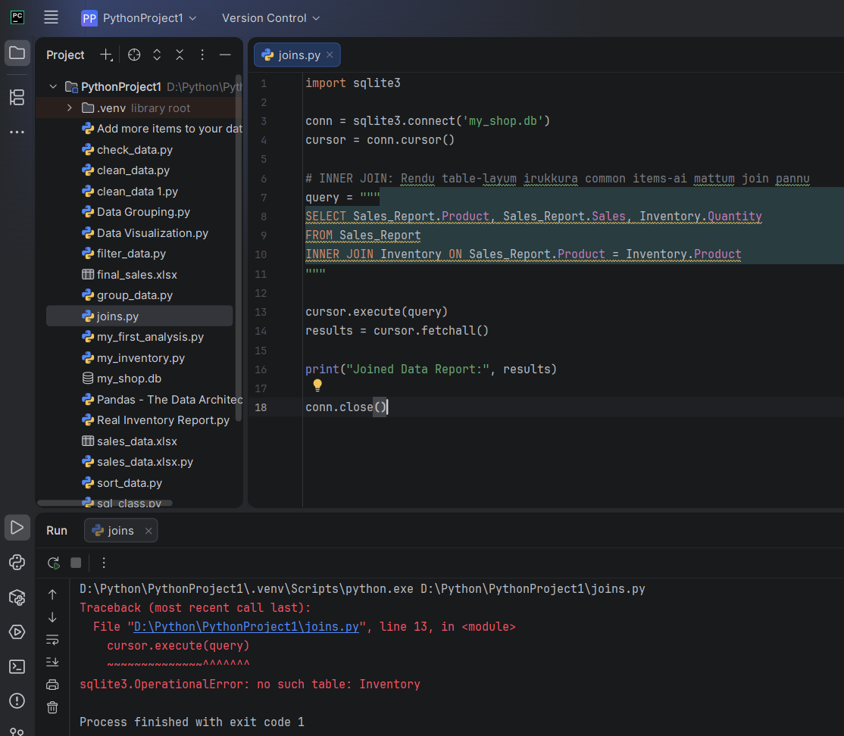
TEACHER IPPADI ERROR VANDICHI
Irshad, error-ai parthuten! sqlite3.OperationalError: no such table: Inventory nu vandhurukku.
Idharku kaaranam simple: Namma database my_shop.db-la Inventory endra table innum create pannala. JOIN panna, rendu table-yum database-kulla irukkanum.
🛠️ Namma ippo Inventory Table-ai create pannuvom
Oru pudhu file create_inventory.py create panni, indha code-ai run pannunga. Idhu unga database-la Inventory table-ai create pannidum:
Python
import sqlite3

conn = sqlite3.connect('my_shop.db')
cursor = conn.cursor()

# 1. Inventory table-ai create panrom
cursor.execute("""
CREATE TABLE IF NOT EXISTS Inventory (
Product TEXT,
Quantity INTEGER
)
""")

# 2. Sila dummy data-vai add panrom
data = [('Laptop', 10), ('Mouse', 50), ('Keyboard', 20), ('Monitor', 15)]
cursor.executemany("INSERT INTO Inventory VALUES (?, ?)", data)

conn.commit()
print("Inventory table ready aayiduchu!")
conn.close()
🔍 Enna nadandhirukku?
- Problem: Namma Inventory table-ai munnadi create pannala, adhan error vandhudhu.
- Solution: Ippo create_inventory.py run panna, unga my_shop.db-kulla Inventory table create aayidum.
Unga Task:
- create_inventory.py-ai run pannunga.
- Adhukku appuram, munnadi namma run panna joins.py file-ai thiruppi run pannunga.
Ippo error pōyidu, correct-ana Joined Data Report kidaikkum. Ready-a Irshad?
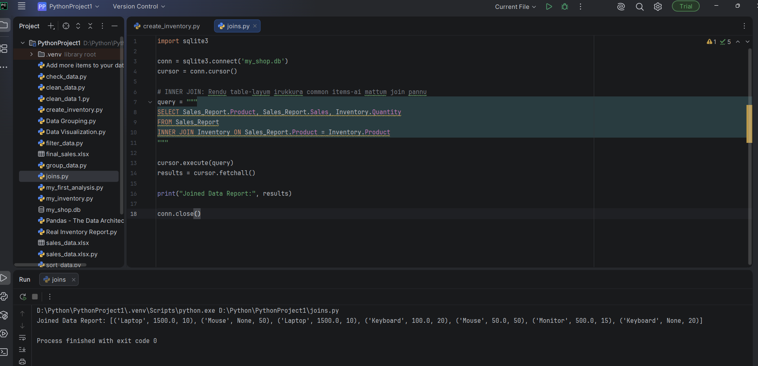
Arumai, Irshad!
Ipothu unga database "Joined Data Report"-ai sariyaaga koduthuvittadhu. Rendu table-il irukkum thagavalgalai (Sales matrum Inventory) inaiithu, orae report-aaga paarkkum thiran ungalukku vandhuvittadhu.
🎓 Analyst's Success Summary:
Neenga ippo oru Full-Stack Data Analyst-aaga maaruvadharku miga arumaiyaana adippadaiyai amaithuvittargal:
- Data Ingestion: Excel-ilirundhu database-kku maatruvadhu.
- Data Cleaning: None valukalai neekki, thagavalgalai sariyaaga vaithiruppadhu.
- Data Integration (Joins): Rendu veruvearu table-galai inaiithu oru summary report eduppadhu.
🌟 Ungaludan oru periya vazhthu!
Neenga unga "Sales Coordinator" velaiyil innum niraiya automatic reports-ai SQL-il ezhudha ippo muzhu thakuthiyum petruvittargal. Adutha kattam, idhai Power BI-il visualization-aaga maatruvadhu dhaan.
Ingirundhu enna seidha nalla irukkum nu ninaikkireenga?
- Innum advanced-a SQL queries (like LEFT JOIN) paarkalama?
- Illa, intha data-vai vachi Python-il charts/graphs panna kathukkollalama?
Unkagaludan payanikka naan migavum magilchiyaaga ullen!

